**DAILY ONLINE ACTIVITIES SUMMARY**

|  |  |  |  |  |  |
| --- | --- | --- | --- | --- | --- |
| **Date:** | **1-06-2020** | | **Name:** | **Shah Dhruvil Amit** | |
| **Sem & Sec** | **6th - B** | | **USN:** | **4AL17CS083** | |
| **Online Test Summary** | | | | | |
| **Subject** | **CNSC** | | | | |
| **Max. Marks** | **60** | **Score** | | **52** | |
| **Certification Course Summary** | | | | | |
| **Course** | **Build an e-commerce with ReactJS** | | | | |
| **Certificate Provider** | **learncodeonline** | **Duration** | | | **As per progress(no duration specified)** |
| **Coding Challenges** | | | | | |
|  | | | | | |
| **Status: executed** | | | | | |
| **Uploaded the report in GitHub** | | **Yes** | | | |
| **If yes Repository name** | | <https://github.com/DhruvilShah99/Daily-Updates> | | | |
| **Uploaded the report in slack** | | **Yes** | | | |

Second IA-CNSC

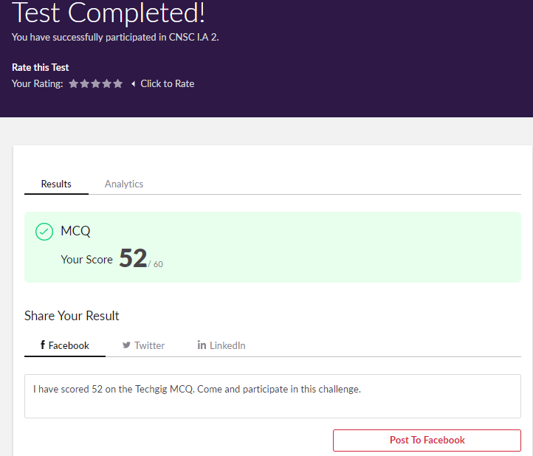

Certification Course Details:

Report

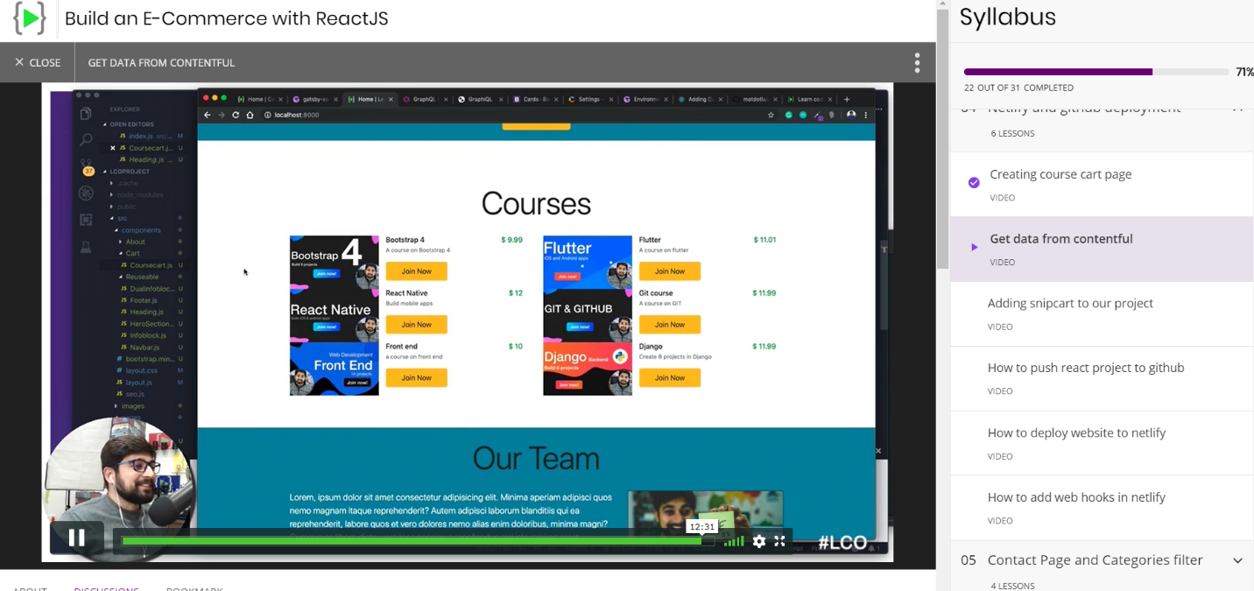

In today’s session for online certification course, I have created courses to be added to the cart and also getting data from the contentful database.

Coding Challenges Details:

The below GitHub link for details

<https://github.com/DhruvilShah99/Daily-Updates>

P-1

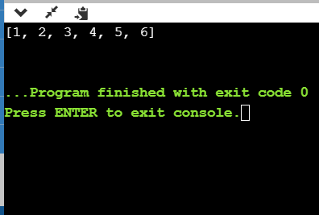

**Python program to remove duplicate values from list**

**P-2**

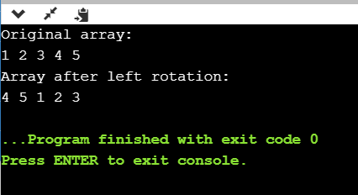

**Java program to rotate the array to left node**

**P-3**

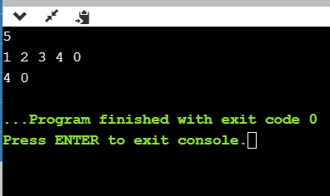

**C program to find the leader in array.**